Manufacturing module

This module enables the creation of products through various production process and this completing the production

creating manufacturing

Manufactoring -> Operations -> Manufacturing Orders -> Create
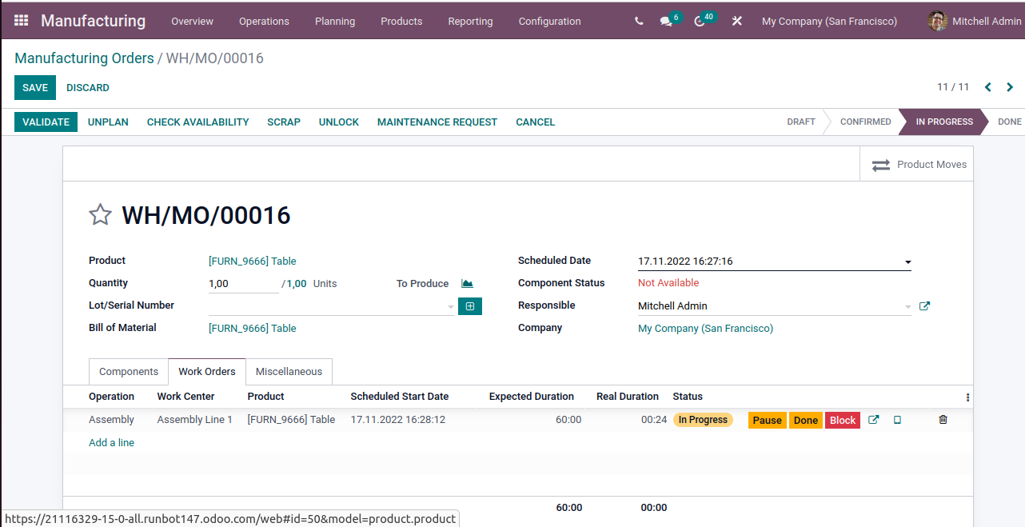
here it is shown that the work is in progress and after complition of the work it goes to done stage

To create Bill of Material(BoM)

Manufacturing-> Products -> Bills of Materials -> Creates
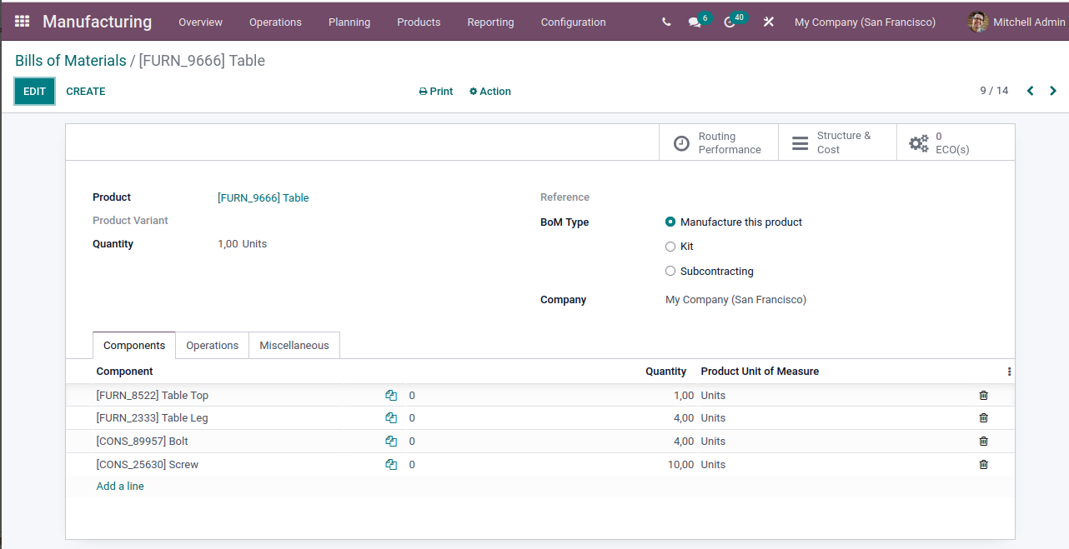
Unbuiled Orders

If a product that you manufactured is damaged then we can goto unbuild orders, its allows the splitting up of the basic components of products and you will get the product after backing stock.

To create Unbuild Orders

Manufacturing -> Operations -> Unbuild Orders

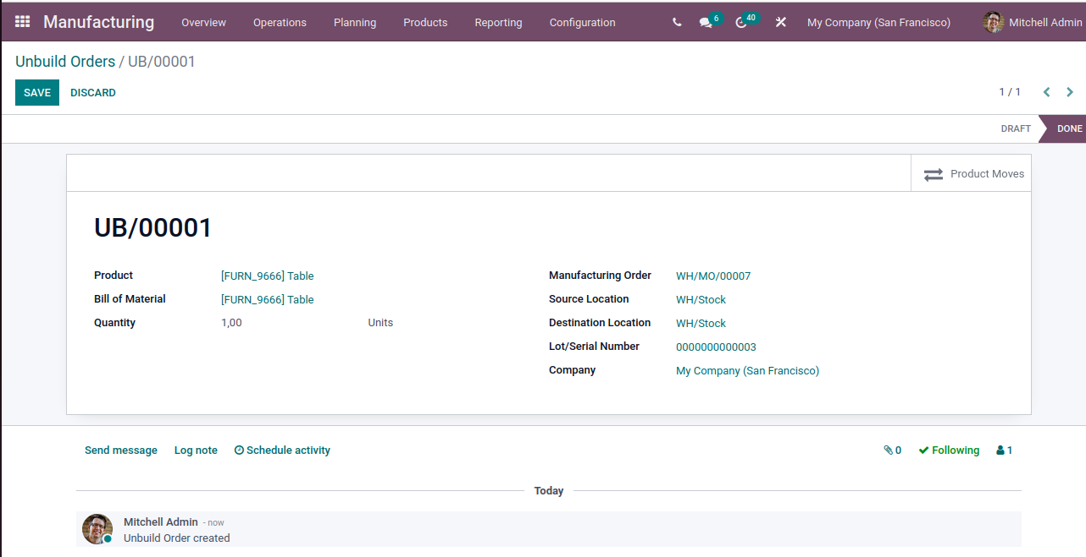
Scrap

A product that does not pass the quality check and cannot be repaired or maintained to make it sale able will be scrapped by the team.

